AI WEATHERWISE
Intelligent Weather Forecasting and AI-Powered Insights

PROJECT REPORT
Backend REST API using Node.js, Express.js, MongoDB and Google Gemini AI

1. Introduction
AI WeatherWise is a robust RESTful backend platform designed to provide real-time weather information together with intelligent, context-aware weather summaries and personalized recommendations. The system uses Node.js and Express.js for backend development, MongoDB with Mongoose for data persistence, OpenWeatherMap for live weather information, and Google Gemini AI for natural-language insights.
The platform also provides secure authentication using JSON Web Tokens (JWT) and password protection using bcrypt. Registered users can manage their favorite locations and request weather information and AI-generated recommendations through REST APIs.
2. Scenario-Based Case Study
2.1 Background
Alex is a travel enthusiast who frequently visits different cities. Alex needs a convenient way to track weather conditions in multiple locations and receive useful activity or clothing suggestions based on current weather conditions.
2.2 Problem Statement
Difficulty tracking and managing multiple favorite weather locations efficiently.
Lack of personalized recommendations for outdoor activities or suitable clothing.
Need for natural-language weather summaries instead of only raw weather metrics.
Need for a secure system to store and synchronize user preferences.
2.3 Proposed Solution
AI WeatherWise provides a centralized backend service for retrieving weather data and generating AI-based insights. It securely manages users and their favorite locations and connects weather information with Google Gemini AI to produce understandable summaries and recommendations.
2.4 System Usage
Registered users can register or log in, manage favorite cities, fetch current weather data, and request AI insights.
Administrators can monitor system activity, user registrations, API health, and database integrity.
Public weather endpoints can provide current weather metrics without requiring a registered account, where enabled.
2.5 Expected Outcome
The system reduces the effort required to interpret raw weather information by combining live weather data with AI-generated summaries and recommendations. MongoDB and Mongoose provide structured data management, while JWT authentication protects secured user operations.

3. System Requirements
3.1 Software Requirements
Operating System: Windows 10/11, macOS, or Linux.
Node.js: Version 16 or above.
npm: Version 8 or above.
Express.js: Backend framework for REST API development.
MongoDB: NoSQL database for storing users and favorite locations.
Mongoose: ODM used for MongoDB schema and database operations.
Google Gemini AI SDK: Used for AI-generated weather summaries and recommendations.
Postman or Thunder Client: Used for API testing.
Visual Studio Code or another suitable code editor.
3.2 Hardware Requirements
Processor: Intel Core i5 (8th Generation or above), AMD Ryzen 5, or equivalent.
RAM: Minimum 8 GB; 16 GB recommended for smoother development and concurrent services.
Storage: At least 1 GB of available project workspace.
4. System Architecture and Design
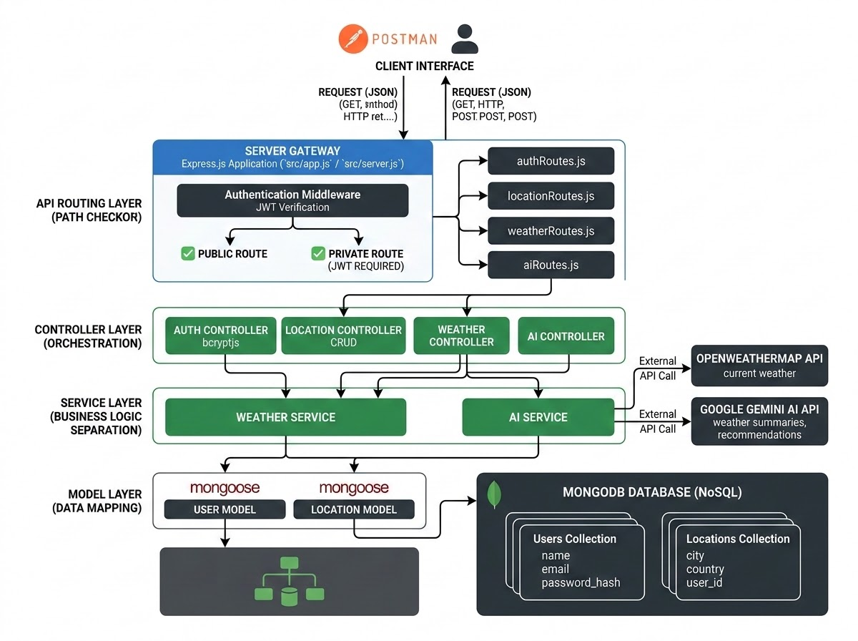
The AI WeatherWise application follows a modular MVC-inspired architecture that separates data models, request handling, routing, authentication, external services, and database operations. This structure improves maintainability, readability, and scalability
4.1 Major Components
API Interface: Postman or another API client sends HTTP requests and receives JSON responses.
Express Server: Handles HTTP methods such as GET, POST, PUT, and DELETE, parses JSON requests, and manages CORS.
Authentication Middleware: Reads JWT tokens, validates the authenticated user, and protects secured routes.
Controller / Service Layer: Processes application requests, retrieves weather data, and coordinates AI insight generation.
Database Interface: Mongoose provides schema definitions and communicates with MongoDB.
Weather Service: Connects to the weather provider to retrieve current weather information.
AI Service: Uses Google Gemini AI to generate weather summaries and personalized recommendations.
4.2 Entity-Relationship Design
The data model contains User and Location entities. A user can have multiple favorite locations, creating a one-to-many relationship between User and Location.

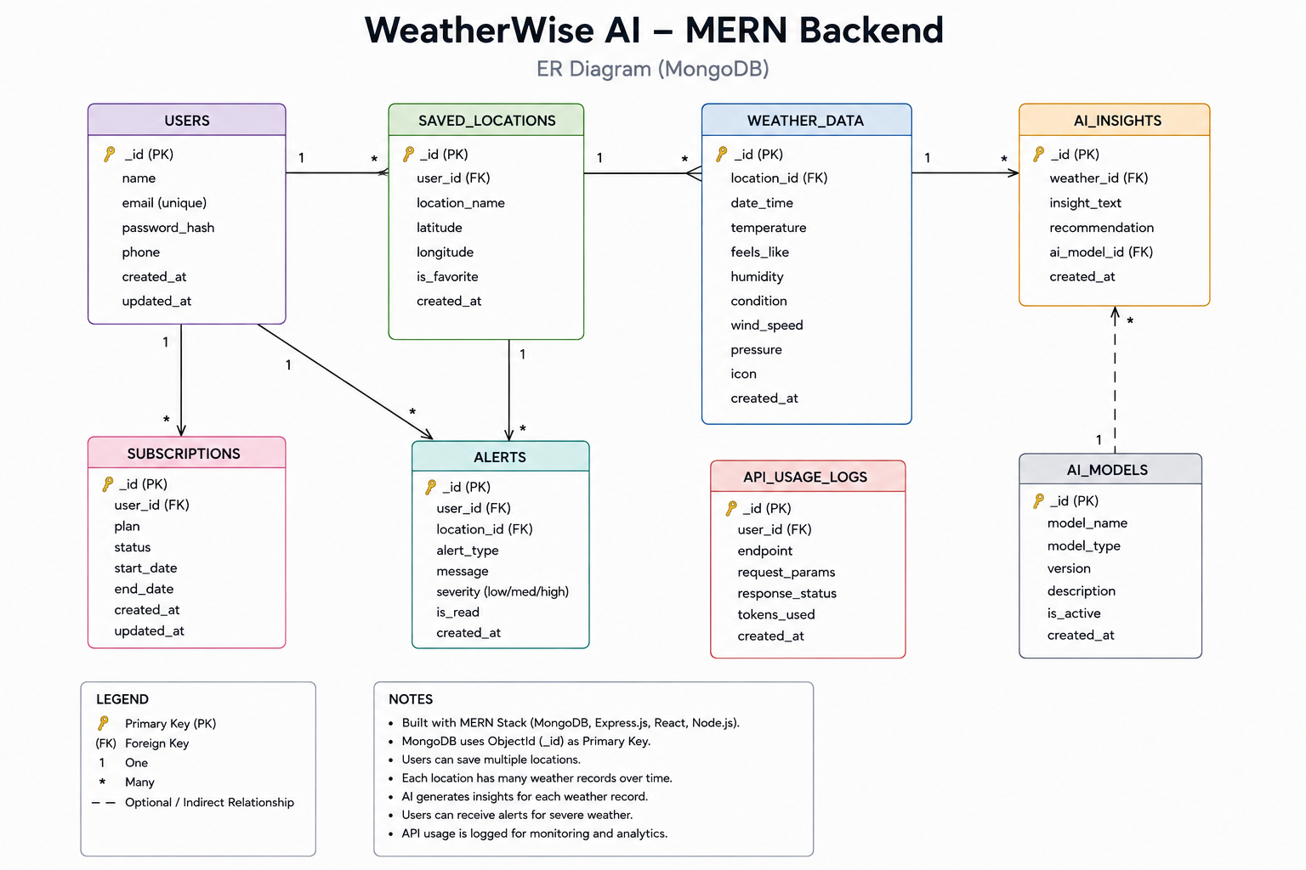

User Entity
_id – Primary key (ObjectId).
name – Required user name.
email – Required and unique email address.
password – Required hashed password.
role – User role, with a default value of reader.
Location Entity
_id – Primary key (ObjectId).
user – Reference to the User collection.
city – Required city name.
country – Required country name.
createdAt – Date and time when the location was created.
Relationship: One User can save multiple favorite Locations (One-to-Many).
4.3 User Flow
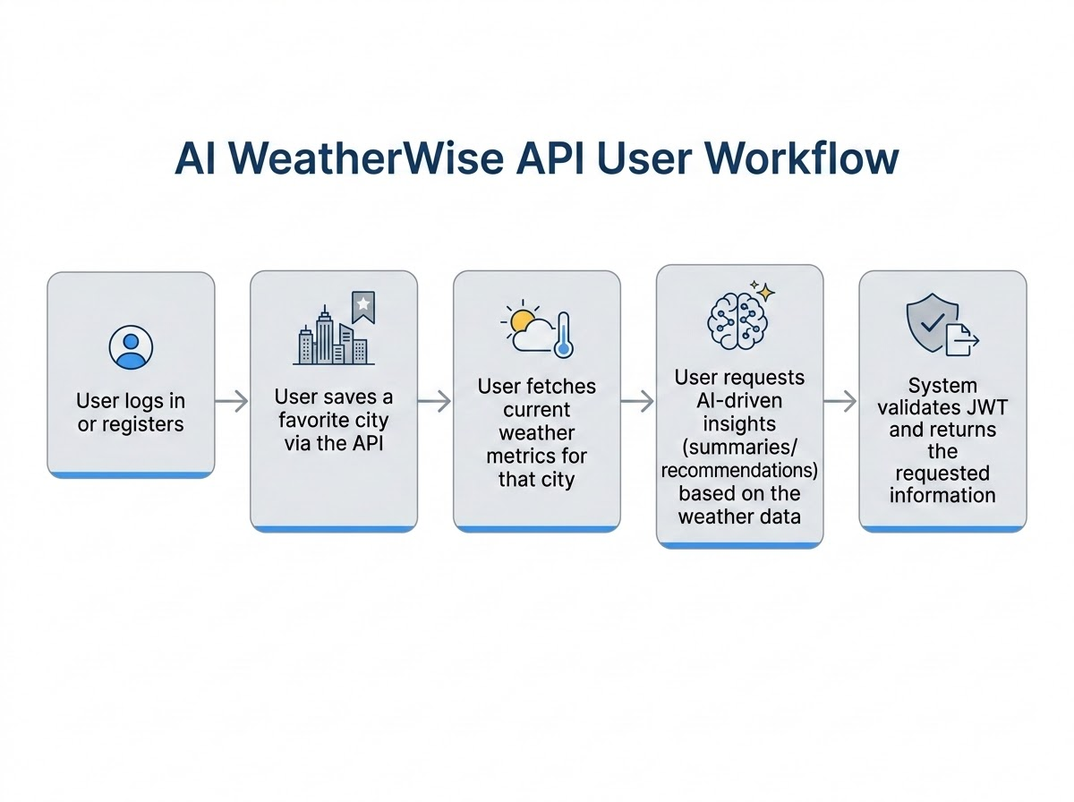
The user registers or logs in.
The authenticated user saves a favorite city.
The user requests current weather information for the selected city.
The system retrieves the weather data.
The user requests AI-generated summaries or recommendations.
The system validates the JWT and returns the requested information.

4.4 MVC-Inspired Architecture

Model Layer
The Model layer defines Mongoose schemas for application data and controls validation, default values, and database persistence.
Controller Layer
The Controller layer receives API requests, validates required input, coordinates business operations, calls database and external services, and returns standardized JSON responses.
Routing / Interface Layer
Because AI WeatherWise is a headless REST API, the interface is represented by API routes rather than traditional web-page views. Routes connect HTTP requests to the appropriate controller logic.
5. Core Features
Secure user registration and login.
JWT-based authentication and protected API routes.
Bcrypt-based password hashing.
Favorite location management using CRUD operations.
Real-time weather data retrieval.
AI-generated weather summaries.
Personalized activity and weather-related recommendations.
Role-based route protection where required.
Request validation and sanitization.
Centralized error handling.
6. Roles and Responsibilities
6.1 Administrator
Manage user accounts and monitor registrations.
Monitor API health and system logs.
Monitor database integrity and system configuration.
6.2 Registered User
Create and maintain favorite locations.
Request real-time weather information.
Request AI-generated weather summaries and recommendations.
Manage authentication and profile information where supported.
7. Project Setup and Configuration
7.1 Project Folder
Create a project folder named AI WeatherWise and open it in Visual Studio Code.
7.2 Project Initialization
npm init -y
Install the required dependencies:
npm install express mongoose bcryptjs jsonwebtoken cors dotenv multer @google/genai
Install Nodemon for development:
npm install --save-dev nodemon
7.3 Main Project Files
index.js
.env
package.json

.gitignore
7.4 Environment Configuration
PORT=5000
MONGO_URI=your_mongodb_connection_string
JWT_SECRET=your_jwt_secret
GEMINI_API_KEY=your_gemini_api_key
Sensitive values such as database credentials, JWT secrets, and API keys should be stored in the .env file and not hard-coded into the application.

8. Backend Development
The backend is developed using Node.js, Express.js, and MongoDB with a modular structure. The application separates routes, controllers, middleware, models, and service logic so that each part of the system has a clear responsibility.

8.1 Application Entry Point – index.js
The index.js file acts as the main entry point. It loads environment variables, creates and configures the Express application, applies middleware, establishes the MongoDB connection, registers API routes, and starts the server.

9. Database Design and Configuration
MongoDB is used as the persistence layer and Mongoose is used as the ODM. The database connection is established before the application processes database-dependent requests.
9.1 Database Configuration Steps
Install the Mongoose package.
Create the MongoDB connection using the configured MONGO_URI.
Define User and Location schemas.


Create Mongoose models from the schemas.



Verify the database connection before processing requests.


9.2 Data Integrity
Required fields, unique email validation, password hashing, references between users and locations, and timestamps help maintain consistent application data.
10. System Execution and API Testing
The AI WeatherWise backend can be executed locally using Node.js. MongoDB must be available and the required environment variables must be configured before starting the application.
10.1 Run the Project
npm install
npm start
After successful startup, the Express server listens for API requests and communicates with MongoDB for database operations.
10.2 API Testing
Register API – verifies user registration.

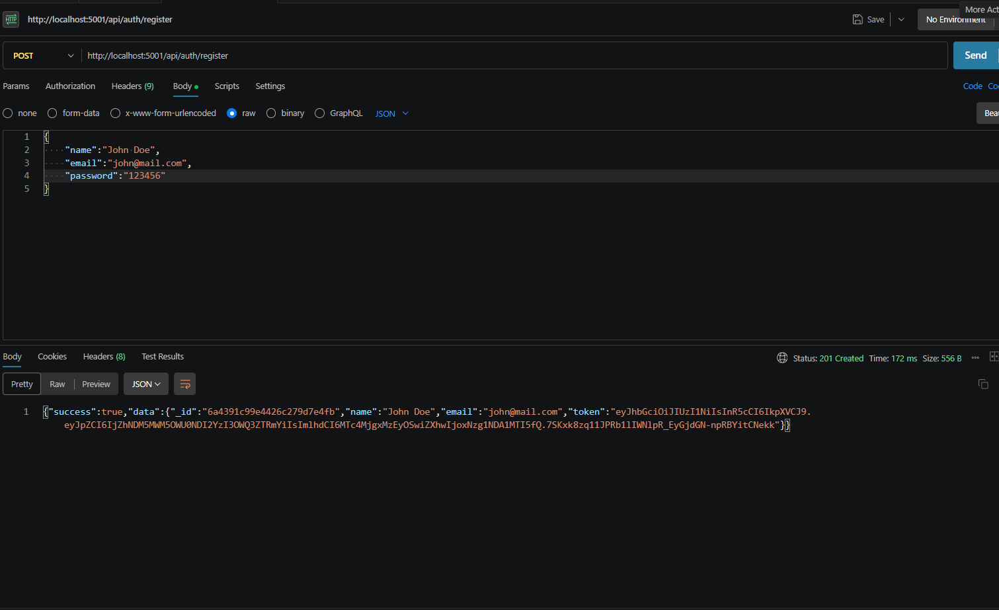

Login API – verifies authentication and JWT generation
.
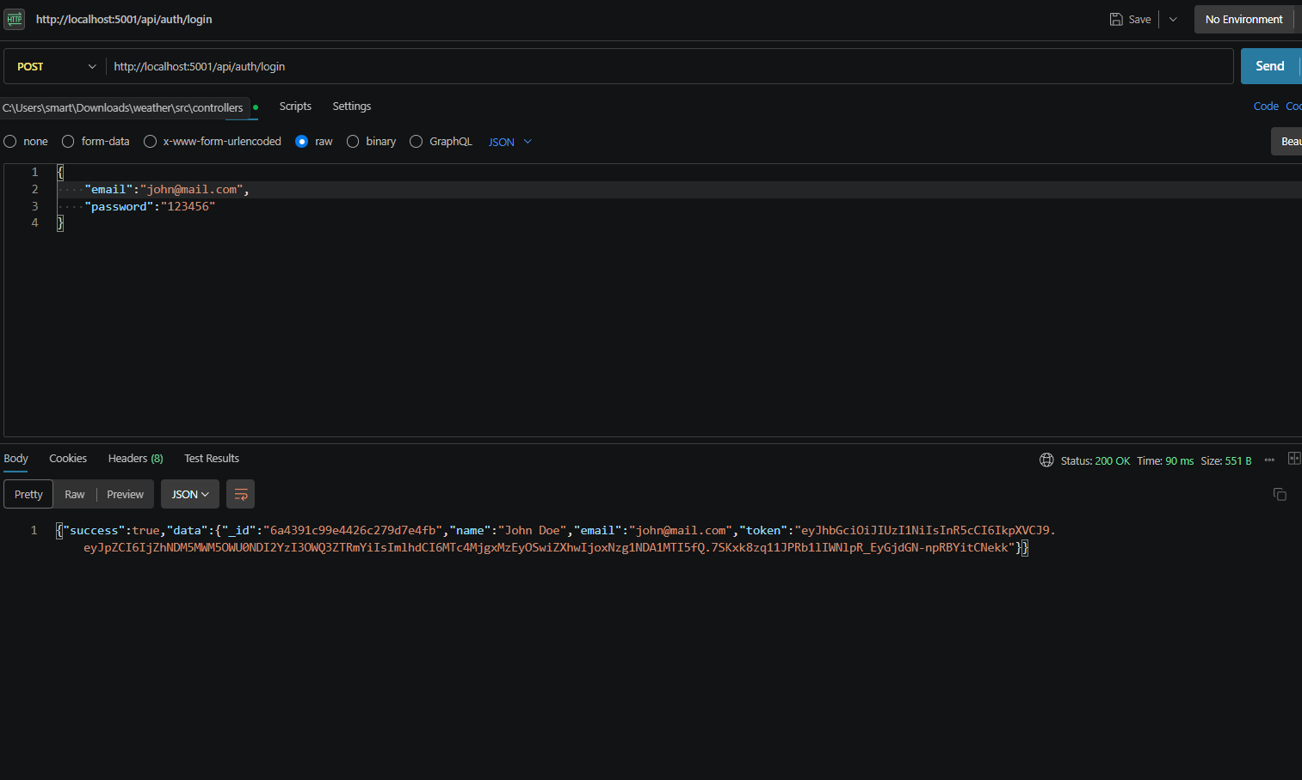

Weather API – verifies retrieval of current weather information
.
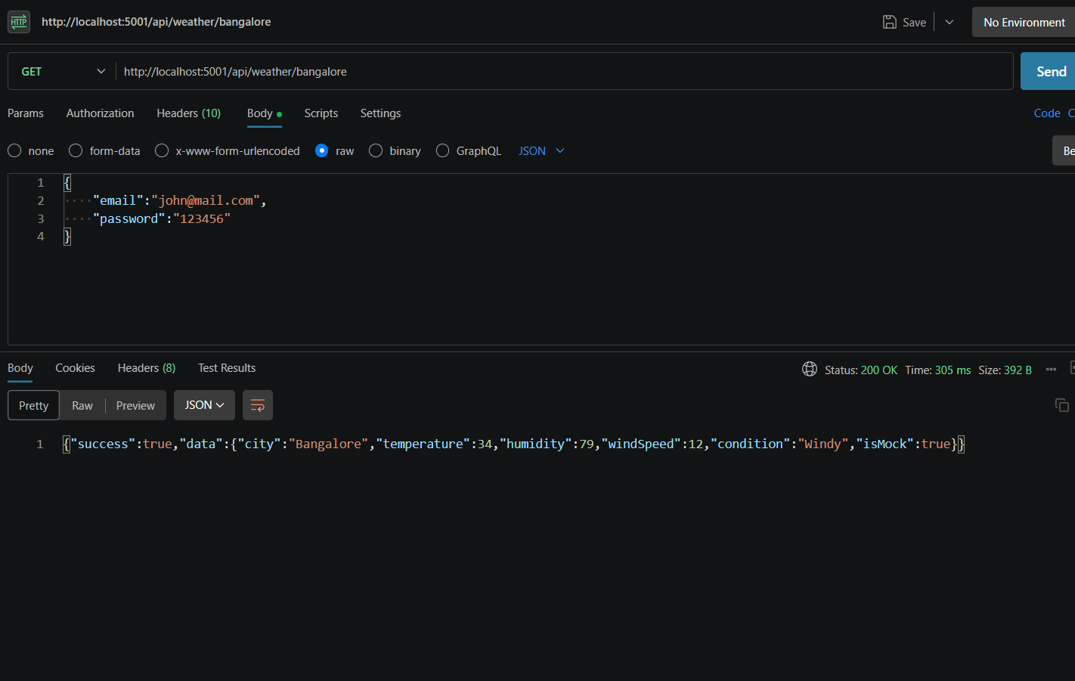
Recommendation API – verifies AI-generated weather recommendations.

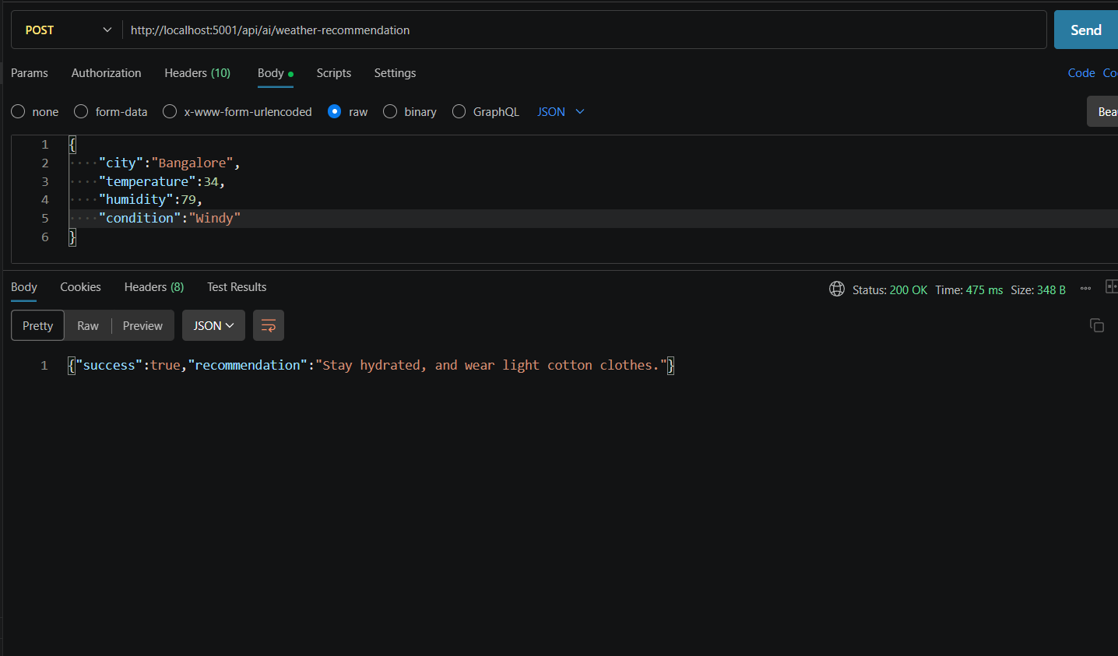
Postman or Thunder Client can be used to test request methods, headers, authentication tokens, request bodies, response status codes, and JSON response structures.
11. Security Measures
Passwords are stored using bcrypt hashing rather than plain text.
JWT authentication is used to protect authenticated resources.
Role-based authorization can restrict sensitive operations.
Environment variables are used for secrets and API credentials.
Request validation and sanitization reduce malformed input and injection risks.
Centralized error handling provides consistent API responses.
12. Testing and Validation
API endpoints should be tested using valid and invalid request data. Authentication-protected endpoints should be checked with valid, missing, expired, or invalid JWT tokens. Database operations should be verified for successful creation, retrieval, update, and deletion of favorite locations.

12.1 Suggested Test Cases

Test Case | Input / Condition | Expected Result
User Registration | Valid details | User account created successfully.
User Login | Valid credentials | JWT token returned.
Protected API | Valid JWT | Requested resource returned.
Protected API | Missing/invalid JWT | Access denied.
Favorite Location | Valid city and country | Location saved.
Weather API | Valid city | Current weather returned.
AI Recommendation | Valid weather context | AI insight returned.
13. Conclusion
AI WeatherWise demonstrates how a RESTful backend can combine live weather data, secure user management, MongoDB persistence, and generative AI to deliver useful weather insights. The modular architecture supports maintainability and future expansion, while API testing provides a practical way to validate the major system functions.
The system can be extended in the future with additional weather data sources, forecast history, alerts, location-based notifications, richer analytics, and a dedicated web or mobile frontend.
14. Project Resources
API Testing Video: https://drive.google.com/file/d/1Kl5AwsotDMLvcKP8hJ0ZjM91Gc5F6vmw/view?usp=sharing
Backend Demo Video: https://drive.google.com/file/d/1LczDW0At0krRY9hmacKucWLsdsR47yV1/view?usp=drive_link
Project Code: https://drive.google.com/drive/folders/11OqDsQnAW3m6Ex3DBNCA1rdUYp_79nuH?usp=sharing

